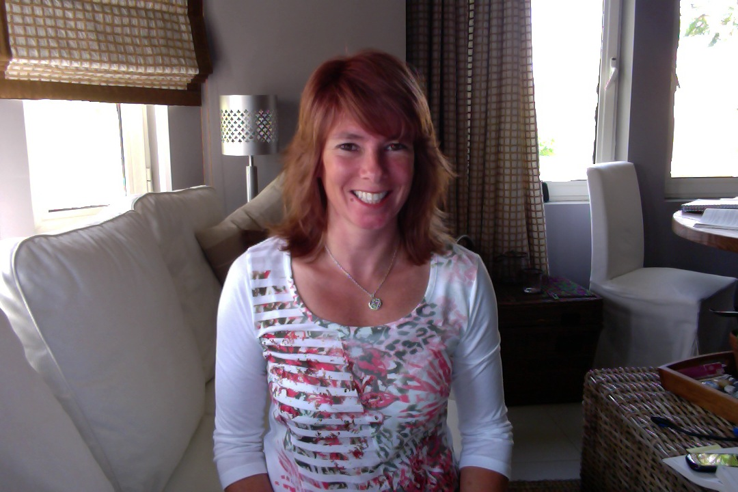

Arlene Gascoine

cc

## Cardinal Dougherty High School 1985

## Legal Secretary/Paralegal/Office Manager from 83–93

## Art Institute of Philadelphia Associates Degree in Interior Design 1993

## Interior Designer in London 93–94; Muscat 94-95, Dubai 95-97

## Married in 94, Mother of 4 – 97, 98, 04, 06

## CTI COACHING CORE CURRICULUM 06-07

## CTI LEADERSHIP SPAIN 07–08

## CTI CERTIFICATION 09-10

## PRIVATE LIFE COACHING PRACTISE FROM 06 - PRESENT

## Ccerc

## LEA

## leaLEA

# Objective: CTI FORL

References Available Upon Request

**Reconnective Healer, certified Matrix Energetics practisioner Pranic Healer, Psychotherapy, Hypnotherapy, NLP, triathlete, crossfitter, raw food vegan**

* [Arlene-lifecoach@live.com](mailto:Arlene-lifecoach@live.com)
* SKYPE: ArleneLifeCoach

+971 50 735 4004

[Date and Time]

[Street Address]